**Weekly Report – 3rd week**

Name :- Vaibhav Bhardwaj

Class :- MCA 3rd Semester

Roll No. :- 2222888

GitHub:- https://github.com/R34L-D34TH/college-report

Day 10:-

* Queue

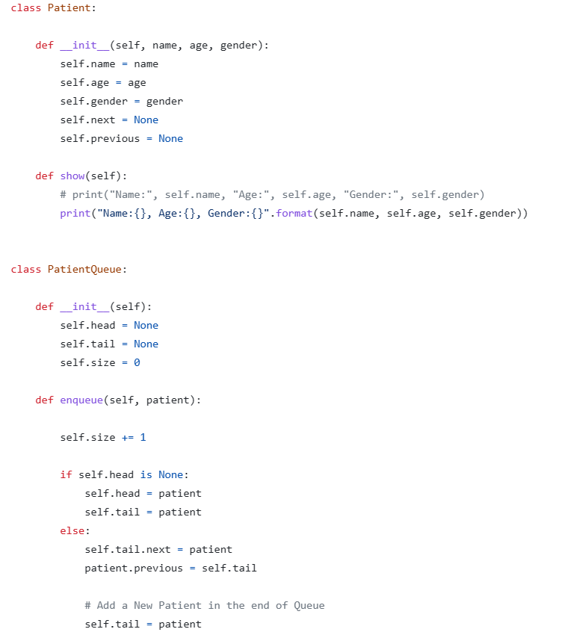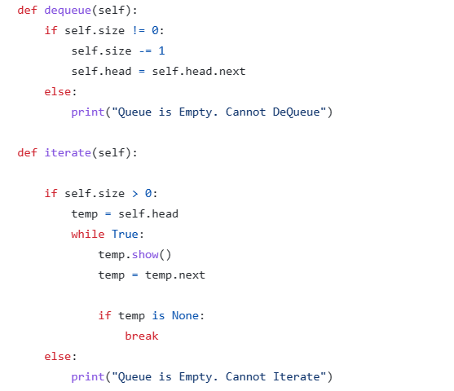Day 11:-

* 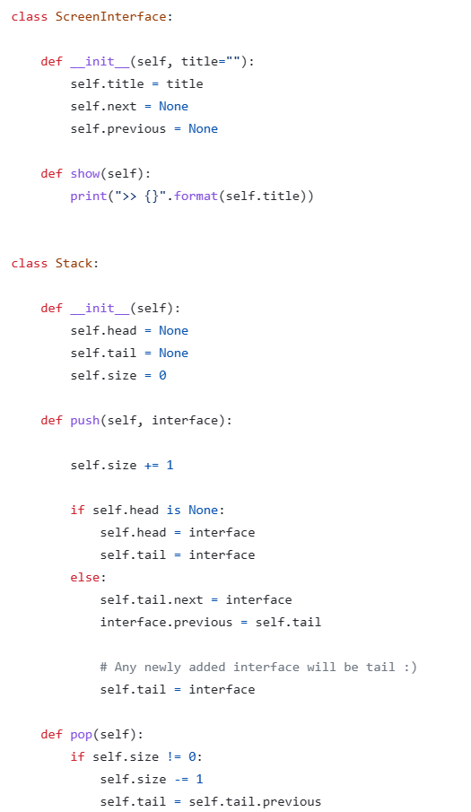Stack

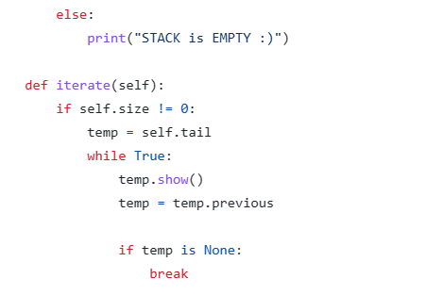

Day 12:-

* Multi-Value Containers
  + 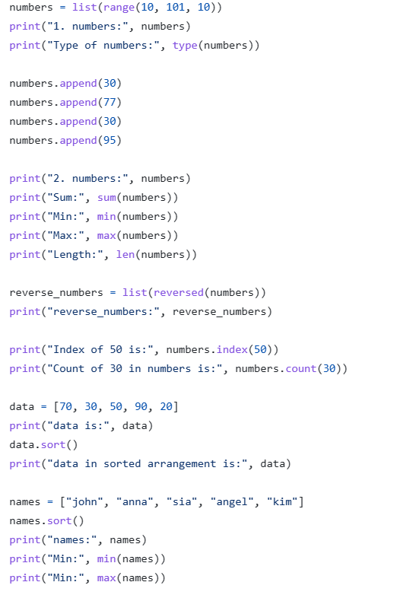List
  + Set

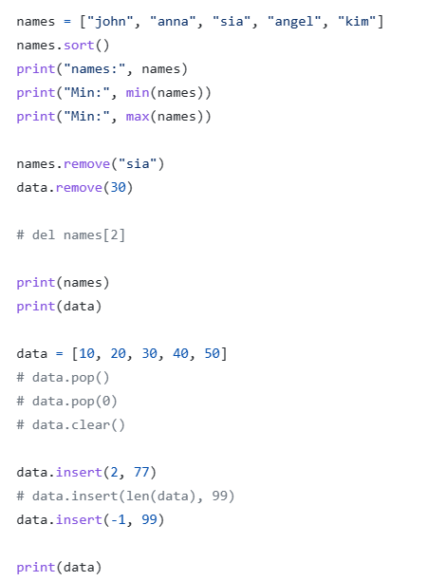

* + 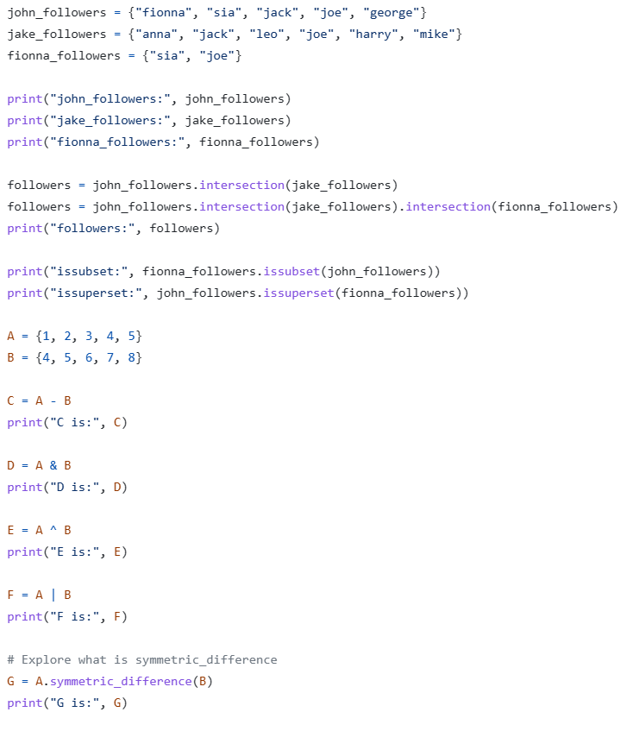Dictionary

Day 13:-

* Strings in Python

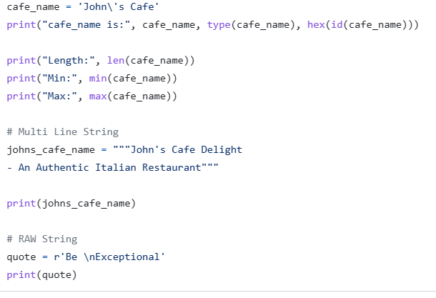

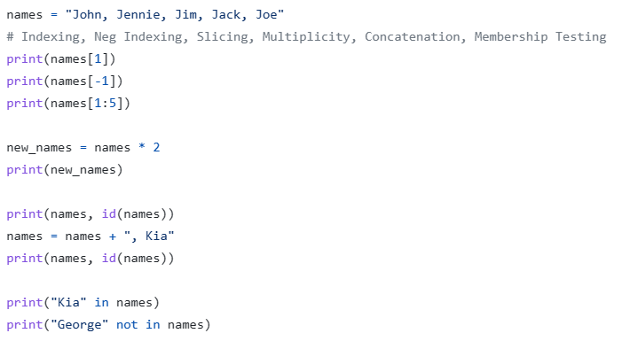

Day 14:-

* Virtual Environment
* 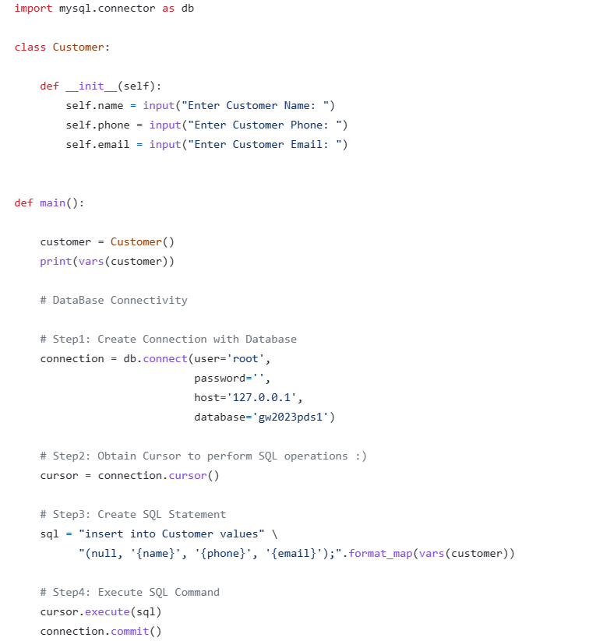Database connectivity with MySQL

